Project Planning Phase

1. Introduction
The Project Planning Phase defines the activities, requirements, resources, and workflow needed to develop the Script-Controlled ACL system.

2. Objective
- To plan the implementation of the Script-Controlled ACL.
- To identify the access requirements and restrictions.
- To define how field values will control record access.
- To plan the scripting and testing activities.
- To ensure that only authorized users can access restricted records.

3. Activities Performed
- Identified the requirement for field-based record access control.
- Identified the table and field to be used for access restriction.
- Defined the conditions under which users can access records.
- Planned the Script-Controlled ACL logic.
- Identified required users, roles, and permissions.
- Planned ACL configuration and script implementation.
- Prepared a testing plan for authorized and unauthorized users.
- Planned documentation of the completed ACL implementation.

4. Expected / Produced Output
- Project requirements identified.
- Access-control rules defined.
- ACL implementation plan prepared.
- Script logic and conditions planned.
- User access scenarios identified.
Screenshot:
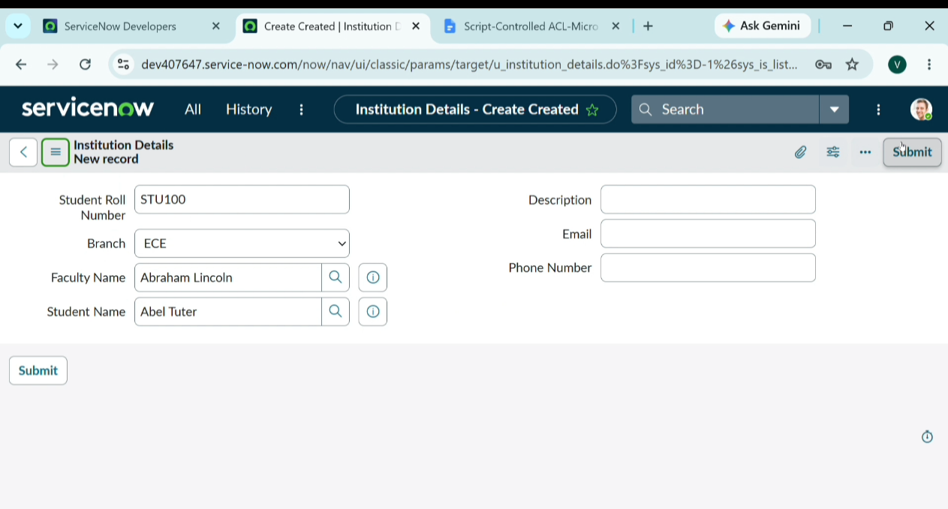

5. Data Flow Diagram
